**Tell us what your idea is**

Our project aims to break away from the shackles of traditional wearable devices and use the sensors inside smart phones to monitor users’ physical health through the program of recognizing gait.

The gait characteristics of the human body can reflect the abnormality of the body in some subliminal or even unconscious circumstances. Therefore, the gait data can be used to detect whether the user is drinking or drunk and to remind the user not to drive. The gait can also be used to judge whether there is any abnormality in the user’s body after movement. If there is any obvious abnormality in the gait, it can timely remind the user. It can also monitor the user's health status based on gait recognition and timely give early warning before the user is in sub-health status or sudden illness.

The purpose of our project is to detect the health status of users. There are three steps in our project. Firstly, we gather the gait data through smart phones with built-in motion sensors and preprocess it. Secondly, training health monitoring model through tensorflow to recognize and classify the state of user’s health (healthy or unhealthy). Thirdly, using tensorflow lite to deploy the model on the mobile device, so as to get rid of the network and improve the real-time and privacy. The model deployed on the smart phone is used to classify the user’s health status. If in the unhealthy state of timely warning, to help users to do the corresponding preventive measures.

**Tell us how you plan on bringing it to life.**

*Describe where your project is, how you could use Google’s help in the endeavor, and how you plan on using On-Device ML technology to bring the concept to life. The best submissions have a great idea combined with a concrete path of where you plan on going, which should include:*

* *(1) any potential sample code you’ve already written,*
* *(2) a list of the ways you could use Google’s help,*
* *(3) as well as the timeline on how you plan on bringing it to life by May 1, 2020.*

**1.** [**Project**](C:/Users/ASUS/AppData/Local/youdao/dict/Application/8.6.2.0/resultui/html/index.html#/javascript:;)[**description**](C:/Users/ASUS/AppData/Local/youdao/dict/Application/8.6.2.0/resultui/html/index.html#/javascript:;)

According to the released big data, the number of sub-healthy people in the world is as high as 75%, while the proportion of truly healthy people is less than 5%. On average, there are at least 10 million people suffering from cancer every year, and at least one person dies of cardiovascular and cerebrovascular diseases every 30 seconds. However, until these diseases actually occur, some minor symptoms do not receive much attention.

The abnormality of any part of our body may lead to the abnormal gait, and even the gait can “find” the abnormality of the body before the consciousness of the person. Therefore, it has good stability and timeliness to measure the health status through the gait recognition.

Our project will use the characteristics of human gait to detect the users’ health status (healthy or not healthy). It is mainly divided into three parts: the design of gait recognition and health status detection model based on deep learning, the research of model compression method, and the design of mobile health detection system based on edge computing. In the first part, we collected users’ gait data through the built-in sensor of mobile phone, preprocessed and extracted the gait data, and then trained the health detection model based on deep learning technology. In the second part, we try to study a suitable model compression method to compress the established model. In the third part, we plan to deploy the compressed model on mobile devices and develop an App to realize the design of mobile health monitoring system based on edge computing, which can identify and classify the user’s health status as “healthy” or “unhealthy”. If the user is in an unhealthy state, it can give an early warning to help the user take corresponding preventive measures. For the elderly who are not good at using mobile phones, we can also deploy the model on wearable devices. Once the gait of the elderly is detected to be obviously abnormal, the wearable devices can contact others in time.

**2. List of requests for Google help**

We will get help from Google by:

1. Using tensorflow to train the health detection model, which is used to realize the identification and classification of users’ health status.
2. Then tensorflow lite developed by Google enables the compressed model to run efficiently on mobile devices.

**3.** [**Scheduled**](C:/Users/ASUS/AppData/Local/youdao/dict/Application/8.6.2.0/resultui/html/index.html#/javascript:;)[**Plan**](C:/Users/ASUS/AppData/Local/youdao/dict/Application/8.6.2.0/resultui/html/index.html#/javascript:;)

|  |  |  |
| --- | --- | --- |
| **Scheduling** | **Primary mission** | [**Estimated**](C:/Users/ASUS/AppData/Local/youdao/dict/Application/8.6.2.0/resultui/html/index.html#/javascript:;)[**time**](C:/Users/ASUS/AppData/Local/youdao/dict/Application/8.6.2.0/resultui/html/index.html#/javascript:;)[**of**](C:/Users/ASUS/AppData/Local/youdao/dict/Application/8.6.2.0/resultui/html/index.html#/javascript:;)[**completion**](C:/Users/ASUS/AppData/Local/youdao/dict/Application/8.6.2.0/resultui/html/index.html#/javascript:;) |
| Design of health test model | Complete the design of health detection model based on gait recognition and carried out the simulation experiment. | January 2020 - April 2020 |
| Research on model compression strategy | Complete the research of model compression strategy and apply it to model compression. | May 2020 - August 2020 |
| Design of mobile health detection system | Complete the software design of college students’ health detection system, and carry out the simulation and test of performance. | September 2020 -December 2020 |

**Tell us about you.**

A great idea is just one part of the equation; we also want to learn a bit more about you. Share with us some of your other projects so we can get an idea of how we can assist you with your project.

I has been studying mobile perception in the field of Internet of things for a long time. During my PhD in Electronic Engineering at Politecnico di Torino, I mainly engaged in the system design and simulation of low-cost RFID tags. During my work in Nanjing University of Posts and Telecommunications and Key Laboratory of Wireless Sensor Network technology in Jiangsu Province. In recent years, I has been mainly engaged in the study of body movement recognition, using emg signals and acceleration signals for recognition.

**I am currently working as a visiting scholar at Worcester Polytechnic Institute in the United States, studying gait recognition and analysis with Professor Emmanuel Agu, which is closely related to the research of this subject and can also provide a good research foundation for this subject.**

Existing relevant research results:

**(1) Electromyographic signal motion recognition based on integrated learning**

I has already had the research foundation of sEMG recognition based on integrated learning in the early stage, and has submitted a paper entitled 《Movements Classification of multi-channel sEMG Based on CNN and Stacking Ensemble Learning》to the journal IEEE ACCESS, which has been published. Figure 1 shows the designed sEMG signal motion recognition model based on integrated learning.

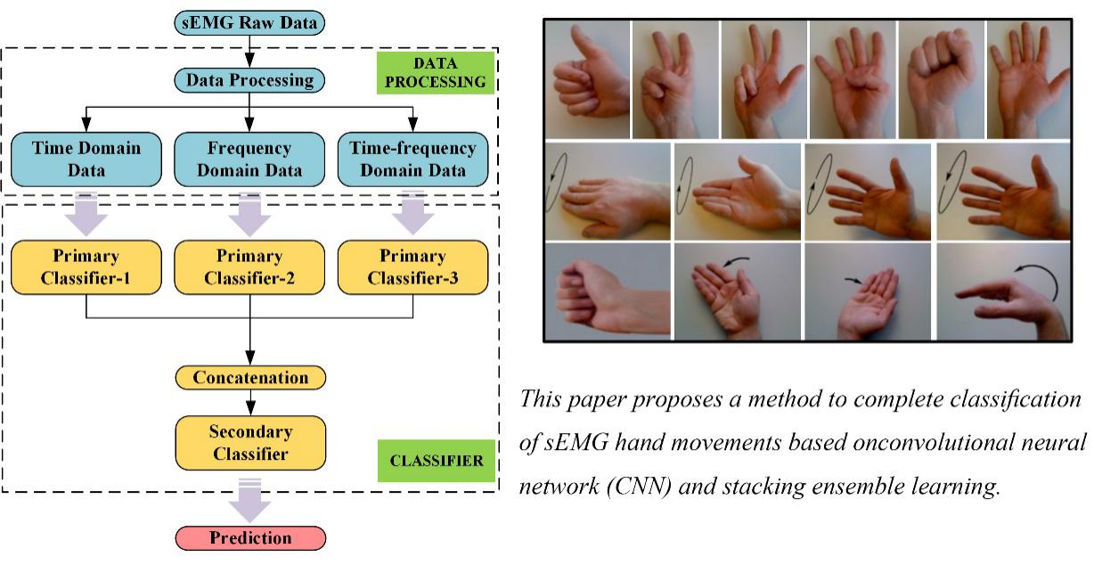

Figure. 1 sEMG signal recognition framework

**(2) Wearable electromyography acquisition device**

I has conducted research on Wearable sEMG acquisition devices in the early stage, and has submitted a paper named《Gesture Recognition through sEMG with Device based on Deep Learning》 to《Mobile Networks and Applications》, a three-area  SCI journal recommended by CCF.

**(3) Electromyographic signal motion recognition based on deep learning**

I has been based on the Deep Learning of electromyographic signal action recognition research, and contribute to the meeting MLICOM 2019 an article, paper, called the 《Motion Classification based on sEMG Signals using Deep Learning》has been published.

Figure 2 shows the designed sEMG signal motion recognition model based on depth neural network.

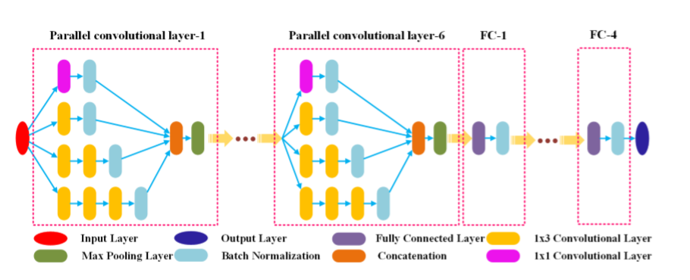

Figure. 2 sEMG motion recognition model

**(4) Design of auxiliary intelligent wearable devices for physical disability**

I has already had the research foundation of wearable disability devices in the early stage, and submitted a paper entitled《Design of auxiliary intelligent wearable system for physical disability》to the journal of computer technology and development on the research results of wearable devices, which has been published. Figure 3 is a schematic diagram of the designed wearable device.



Figure 3. Figure of wearable assistive device

**Next steps.**

* Be sure to include this cover letter in your GitHub repository
* Your GitHub repository should be tagged #AndroidDevChallenge
* Don’t forget to include other items in your GitHub repository to help us evaluate your submission; you can include prior projects you've worked on, sample code you've already built for this project, or anything else you think could be helpful in evaluating your concept and your ability to build it
* [**The final step is to fill out this form to officially submit your proposal.**](https://docs.google.com/forms/d/e/1FAIpQLSe43koQL33IzgxXQl29Ex3AhFuqd4hQzxLiXREqwRkDGtx1vA/viewform?usp=sf_link)